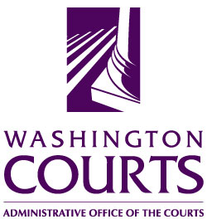

June 19, 2018

TO: Judicial and Legal Communities

FROM: Merrie Gough, Senior Legal Analyst

SUBJECT: 2018 SUMMARY OF CHANGES TO UNLAWFUL HARASSMENT FORMS

The Washington Pattern Forms Committee approved the recommended changes to the model Unlawful Harassment forms.

The table below contains detailed descriptions of the changes:

No. | Form No. | Title and description of changes.
1. | UH 03.0200 | Temporary Protection Order and Notice of hearing – Harassment  On page two, below the heading for “Service,” change the last two service options as follows:  Or Petitioner has madeshall make private arrangements for service of this order.  Or Respondent appeared in person before the court; further service is not required under RCW 10.14.100(5). Respondent appeared; further service is not required.
2. | UH 03.0300 | Reissuance of Temporary Order for Protection and Notice of Hearing  Delete the text in the box with WACIC data entry and service provisions and replace the text with the following:  “Washington Crime Information Center (WACIC) Data Entry  It is ordered that the clerk of court shall forward a copy of this order on or before the next judicial day to: _________________________________ County Sheriff’s Office Police Department where petitioner lives which shall enter it into WACIC.  Service  The clerk of court petitioner shall forward a copy of this order on or before the next judicial day to: ______________________________________ County Sheriff’s Office Police Department where respondent lives which shall personally serve the respondent with a copy of this order and shall promptly complete and return to this court proof of service.  Or Petitioner shall make private arrangements for service of this order.  Or Respondent appeared in person before the court; further service is not required under RCW 10.14.100(5).”

